|  |
| --- |
| **Workstation location and number (if applicable): ........Middlesbrough college....... User: Lilly Griffiths (M2201454)**  **Checklist completed by: Lilly Griffiths (M2201454)**  **Assessment checked by: .............................................**  **Any further action needed: Yes / No**  **Follow-up action completed on: .............................................** |

**Display screen equipment (DSE) workstation checklist**

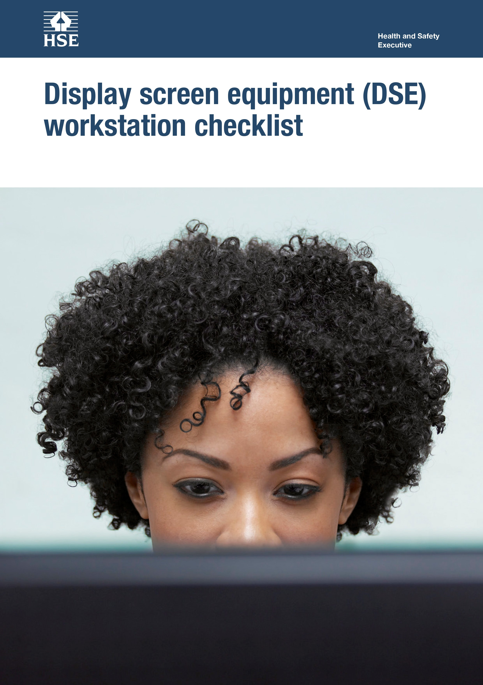

This is a web-friendly version of *Display screen equipment (DSE) workstation checklist* published 05/13

The following checklist can be used to help you complete a risk assessment and comply with the Schedule to the Health and Safety (Display Screen Equipment) Regulations 1992 as amended by the Health and Safety (Miscellaneous Amendments) Regulations 2002.

The questions and ‘Things to consider’ in the checklist cover the requirements of the Schedule. If you can answer ‘Yes’ in the second column against all the questions, having taken account of the ‘Things to consider’, you are complying. You will not be able to address some of the questions and ‘Things to consider’, eg on reflections on the screen, or the user’s comfort, until the workstation has been installed. These will be covered in the risk assessment you do once the workstation is installed.

**Health and Safety**

**Executive**

Work through the checklist, ticking either the ‘Yes’ or ‘No’ column against each risk factor:

■ ‘Yes’ answers require no further action.

■ ‘No’ answers will require investigation and/or remedial action by the workstation assessor. They should record their decisions in the ‘Action to take’ column. Assessors should check later that actions have been taken and have resolved the problem.

Remember, the checklist only covers the workstation and work environment. You also need to make sure that risks from other aspects of the work are avoided, eg by giving users health and safety training, and providing for breaks or changes of activity. For more advice on these see *Working with display screen equipment (DSE): A brief guide*.

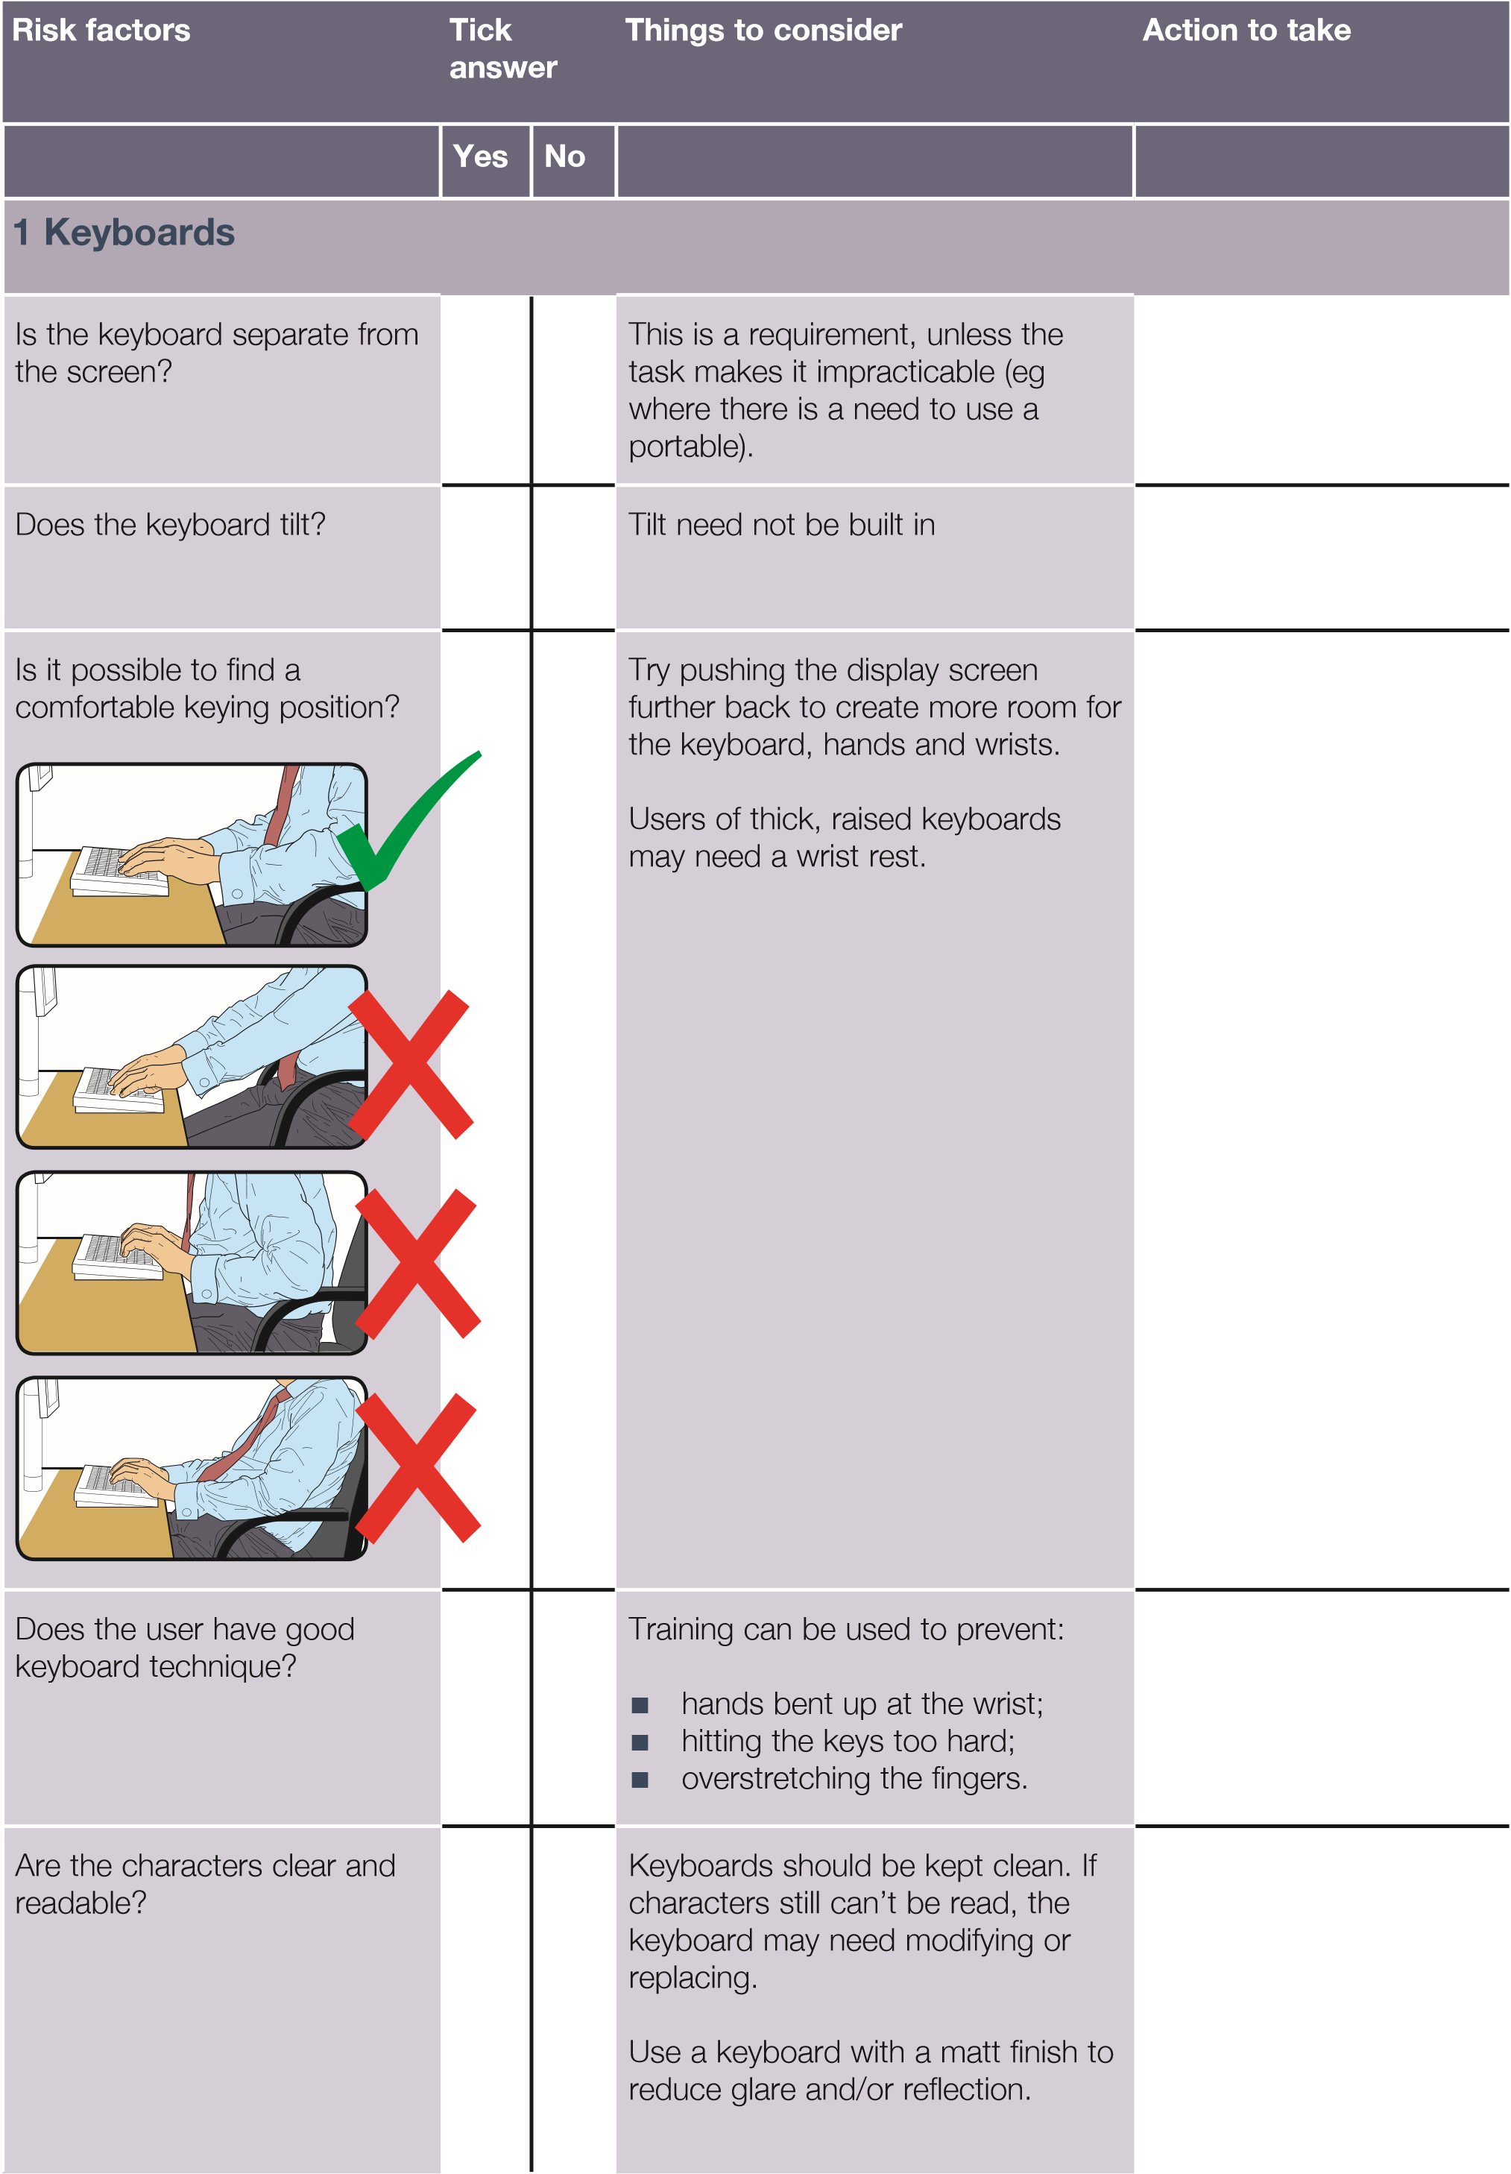



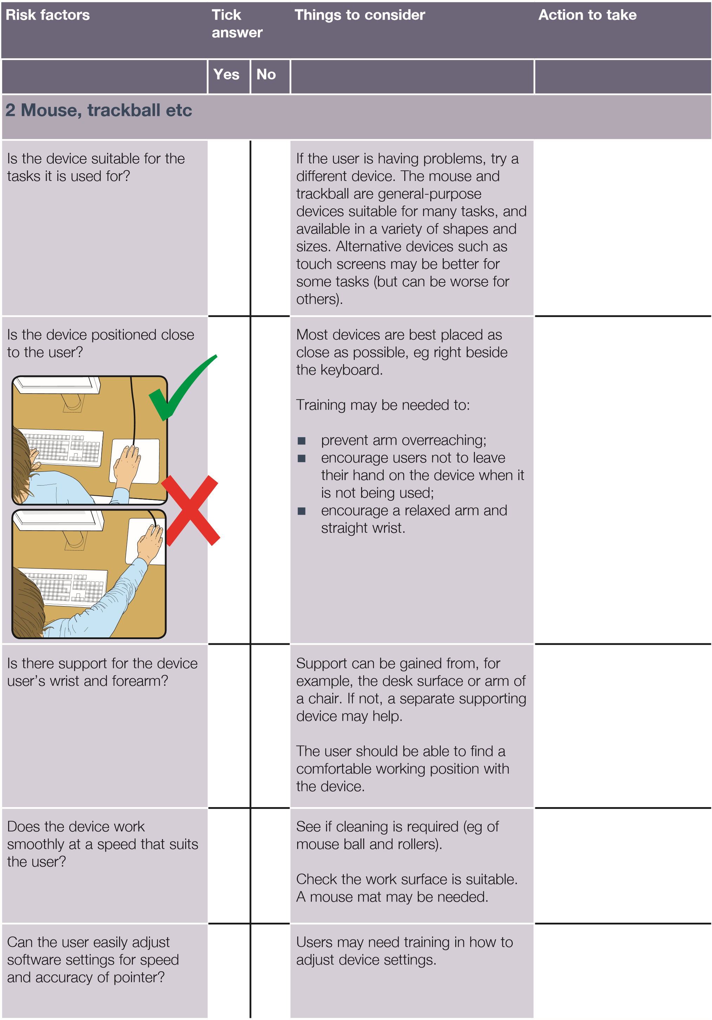



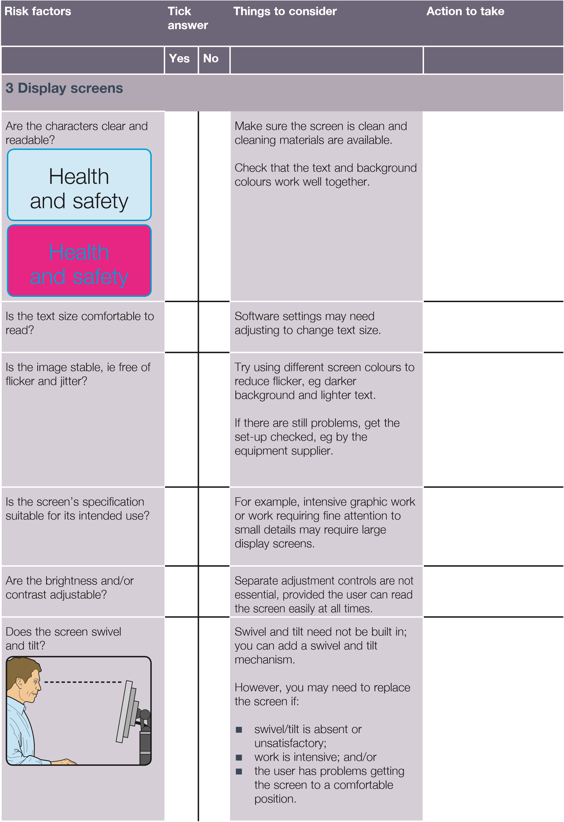



**Risk factors**

**Tick**

**answer**

**Things to consider**

**Action to take**

**Yes**

**No**

Is the screen free from glare

and reflections?

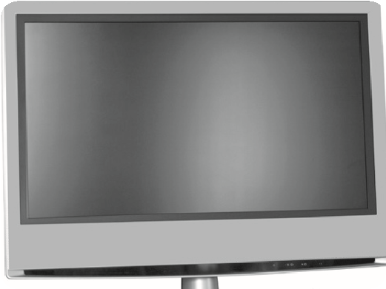

Use a mirror placed in front of the

screen to check where reflections

are coming from.

You might need to move the

screen or even the desk and/or

shield the

screen from the source of

the reflections.

Screens that use dark characters

on a light background are less

prone to glare and reflections.

Are adjustable window

coverings provided and in

adequate condition?

Check that blinds work. Blinds with

vertical slats can be more suitable

than horizontal ones.

If these measures do not work,

consider anti-glare screen filters as a

last resort and seek specialist help.

**4**

**Software**

Is the software suitable for the

task?

Software should help the user carry

out the task, minimise stress and be

user-friendly.

Check users have had appropriate

training in using the software.

Software should respond quickly

and clearly to user input, with

adequate feedback, such as clear

help messages.

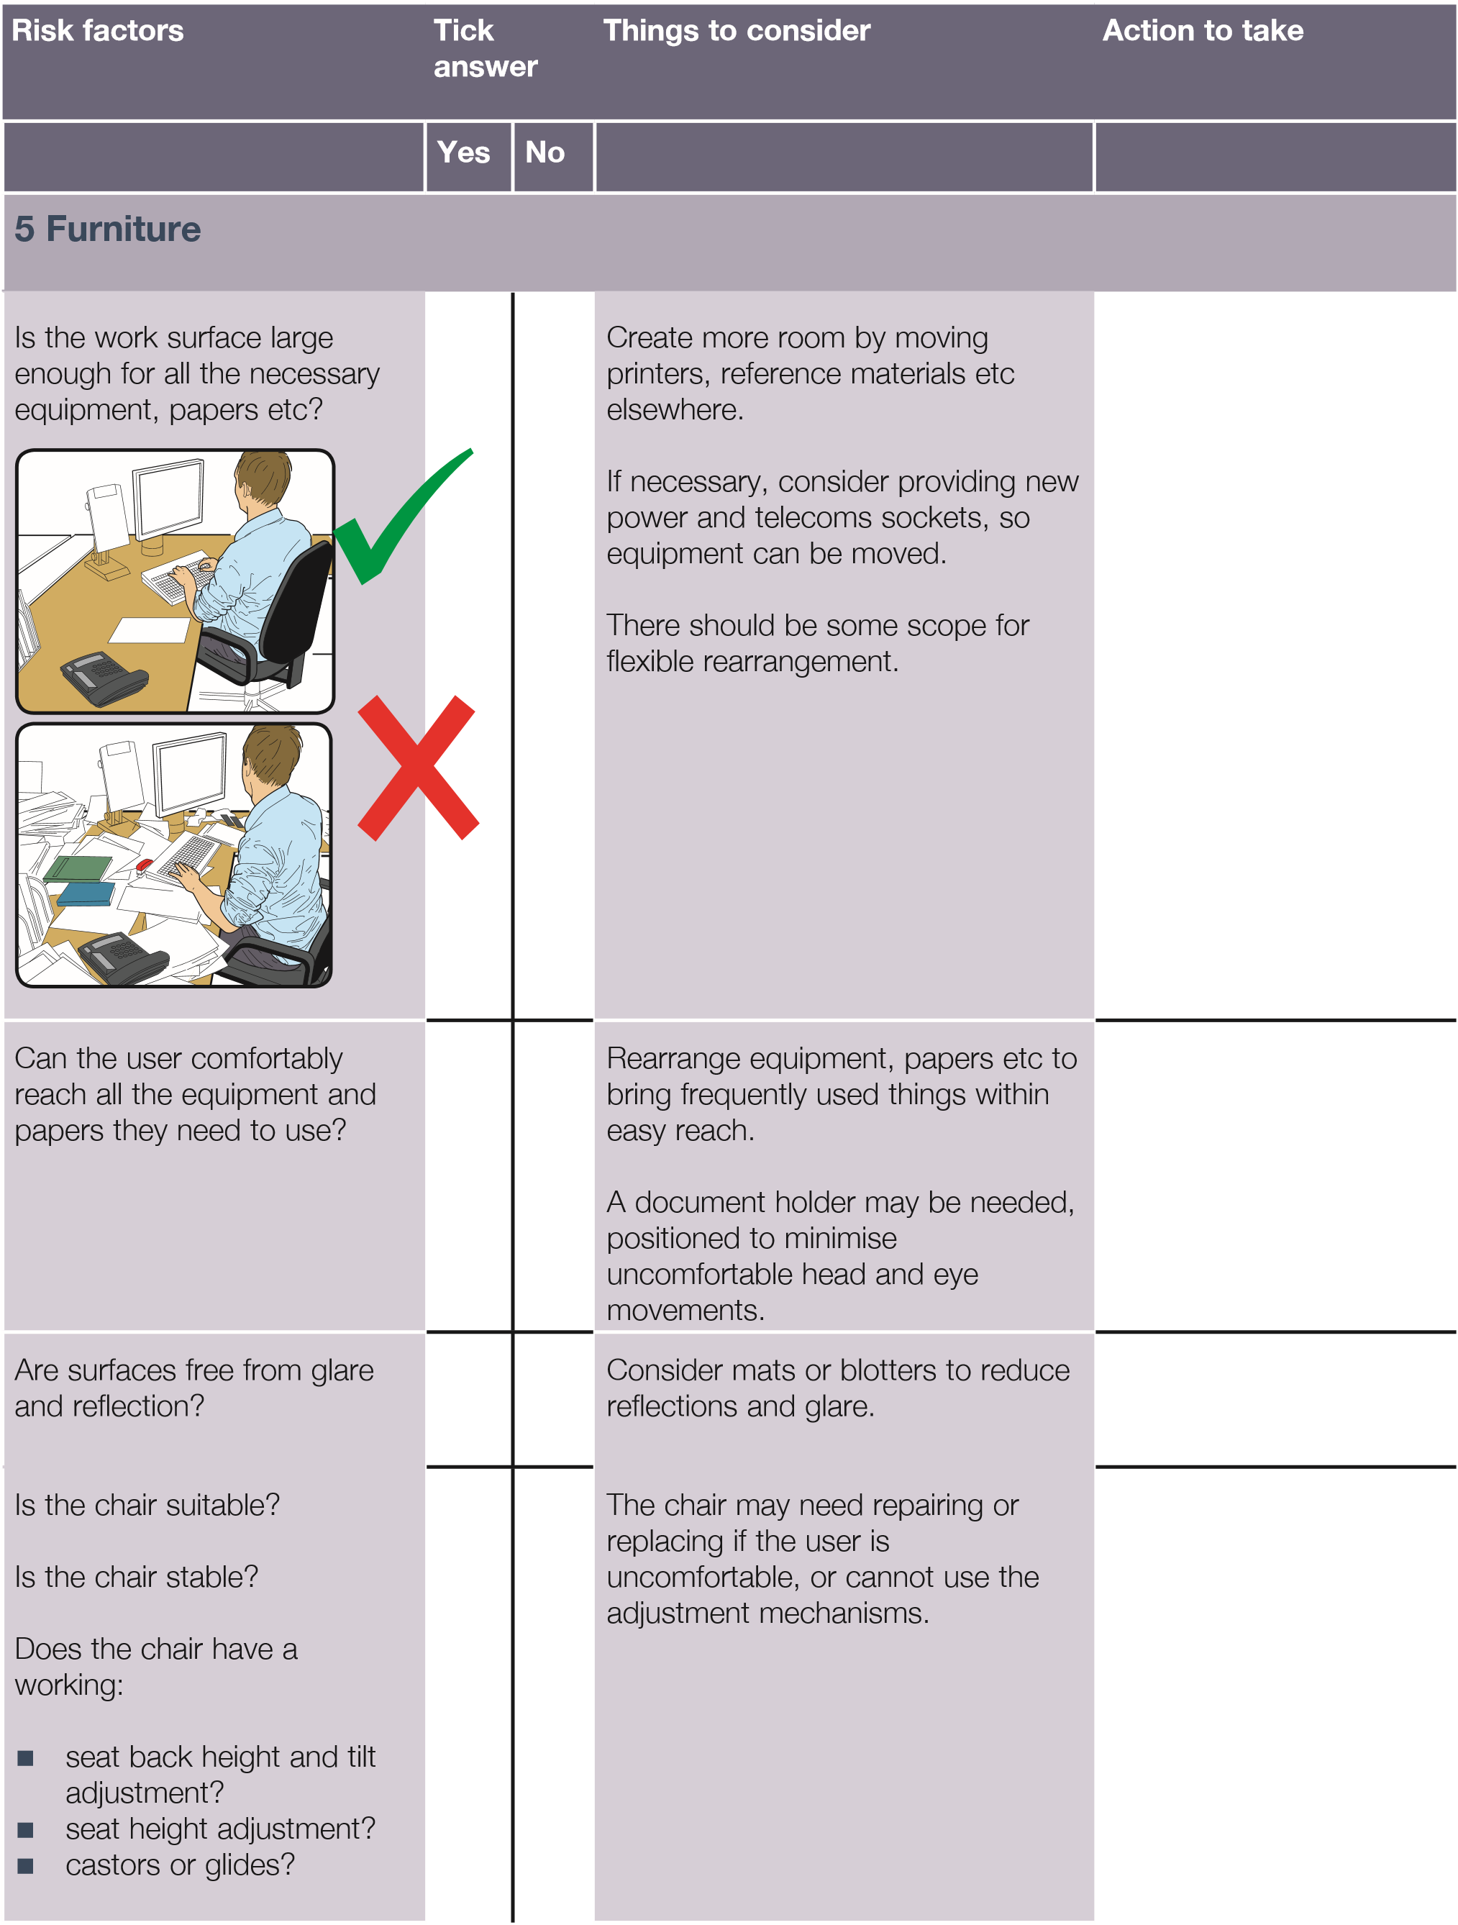



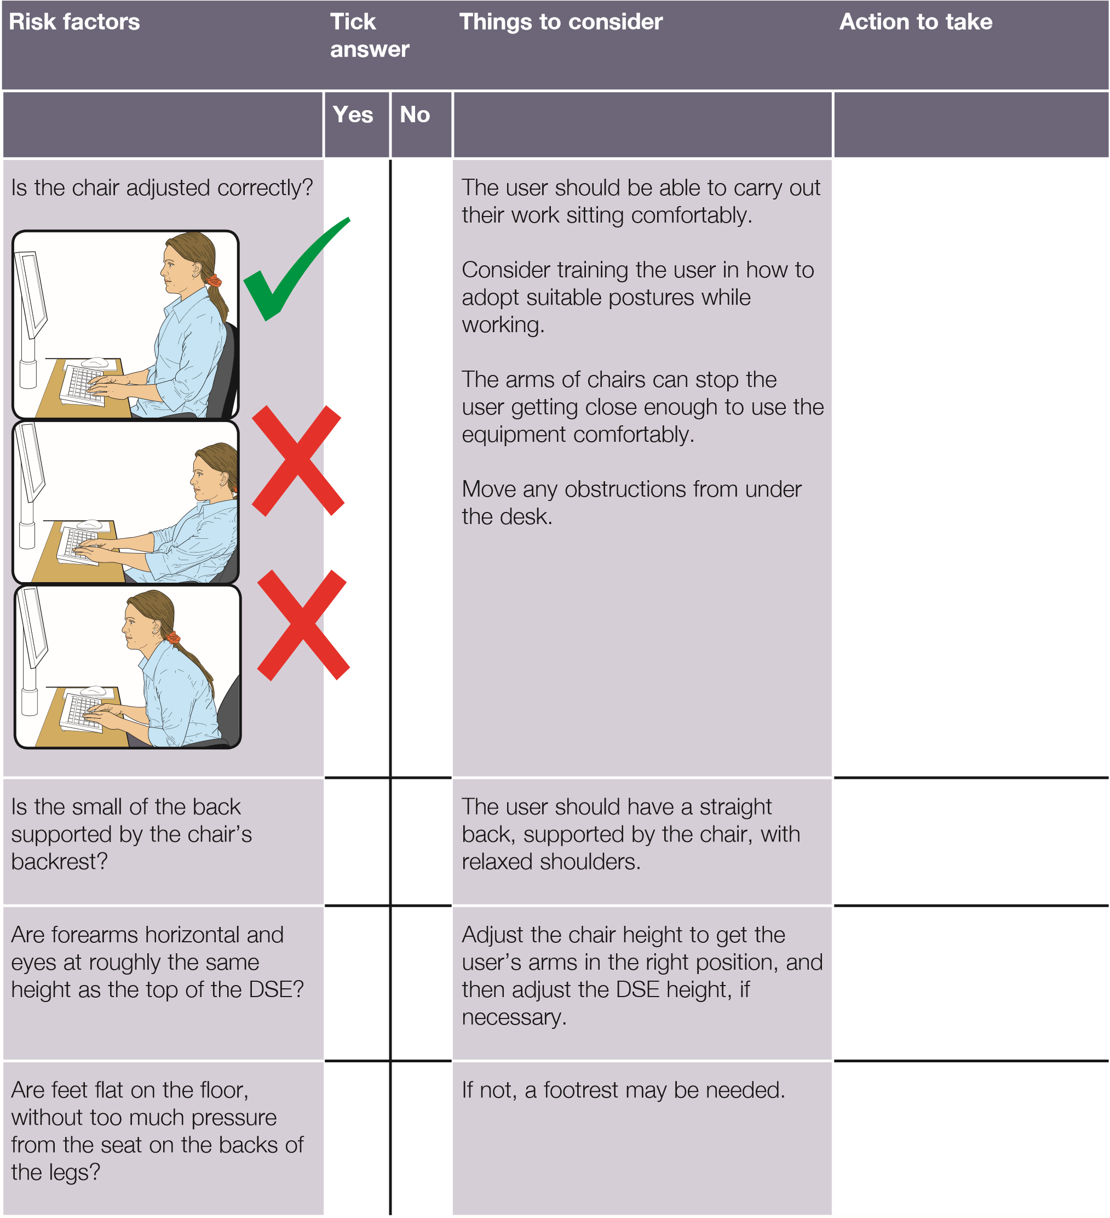



**Risk factors**

**Tick**

**answer**

**Things to consider**

**Action to take**

**Yes**

**No**

**6**

**Environment**

Is there enough room to

change position and vary

movement?

Space is needed to move, stretch

and fidget.

Consider reorganising the office

layout and check for obstructions.

Cables should be tidy and not a trip

or snag hazard.

Is the lighting suitable, eg not

too bright or too dim to work

comfortably?

Users should be able to control light

levels, eg by adjusting window

blinds or light switches.

Consider shading or repositioning

light sources or providing local

lighting, eg desk lamps (but make

sure lights don’t cause glare by

reflecting off walls or other

surfaces).

Does the air feel comfortable?

DSE and other equipment may dry

the air.

Circulate fresh air if possible. Plants

may help.

Consider a humidifier if discomfort is

severe.

Are levels of heat

comfortable?

Can heating be better controlled?

More ventilation or air conditioning

may be required if there is a lot of

electronic equipment in the room.

Or, can users be moved away from

the heat source?

Are levels of noise

comfortable?

Consider moving sources of noise,

eg printers, away from the user. If

not, consider soundproofing.

**7 Final questions to users...**

■ Has the checklist covered all the problems they may have working with their DSE?

Yes

■ Have they experienced any discomfort or other symptoms which they attribute to working with their DSE?

No

■ Has the user been advised of their entitlement to eye and eyesight testing?

Yes

■ Does the user take regular breaks working away from DSE?

Yes

**Write down the details of any problems here:**

# Further information

*Working with display screen equipmemt (DSE): A brief guide* Leaflet INDG36(rev4) HSE books 2013 [www.hse.gov.uk/pubns/indg36.htm](http://www.hse.gov.uk/pubns/indg36.htm)

For information about health and safety visit [https://books.hse.gov.uk](https://books.hse.gov.uk/) or [http://www.hse.gov.uk.](http://www.hse.gov.uk/) You can view HSE guidance online and order priced publications from the website. HSE priced publications are also available from bookshops.

To report inconsistencies or inaccuracies in this guidance email: commissioning@wlt.com

British Standards can be obtained in PDF or hard copy formats from BSI: [http://shop.bsigroup.com](http://shop.bsigroup.com/) or by contacting BSI Customer Services for hard copies only Tel: 0846 086 9001 Email: mailto:cservices@bsigroup.com

The Stationery Office publications are available from The Stationery Office,

PO Box 29, Norwich NR3 1GN Tel: 0333 202 5070 Fax: 0333 202 5080. Email: customer.services@tso.co.uk Website: [http://www.tso.co.uk.](http://www.tso.co.uk/) They are also available from bookshops.

Statutory Instruments can be viewed free of charge at [http://www.legislation.gov.uk](http://www.legislation.gov.uk/) where you can also search for changes to legislation.

*© Crown copyright 2013*

First published 2013

ISBN 978 0 7176 6521 1

You may reuse this information (excluding logos) free of charge in any format or medium, under the terms of the Open Government Licence. To view the licence visit [www.nationalarchives.gov.uk/doc/open-government-licence/,](http://www.nationalarchives.gov.uk/doc/open-government-licence/) write to the Information Policy Team, The National Archives, Kew, London TW9 4DU, or email psi@nationalarchives.gsi.gov.uk.

Some images and illustrations may not be owned by the Crown so cannot be reproduced without permission of the copyright owner. Enquiries should be sent to copyright@hse.gsi.gov.uk.

This guidance is issued by the Health and Safety Executive. Following the guidance is not compulsory, unless specifically stated, and you are free to take other action. But if you do follow the guidance you will normally be doing enough to comply with the law. Health and safety inspectors seek to secure compliance with the law and may refer to this guidance.